What is Deep Learning?
Deep learning is a subset of machine learning concerned with algorithms inspired by the structure and function of the human brain. Deep learning systems can handle massive amounts of structured and unstructured data. The key notion of deep learning is artificial neural networks, which allow machines to make decisions.
The primary distinction between deep learning and machine learning is how data is delivered to the machine. Deep learning networks function on numerous layers of artificial neural networks, whereas machine learning algorithms often require structured input.
A primary neural network looks like this:
- The network has an input layer that takes data inputs.
- The hidden layer searches for any hidden characteristics in the data.
- The output layer subsequently provides the expected output.
Here's an example of a neural network that uses enormous amounts of unlabeled retinal data. This data is used to train the network model, which determines whether or not a person has diabetic retinopathy.

Why is Deep Learning important?
In a word, Deep Learning achieves higher recognition accuracy levels than ever before. This assists consumer electronics in meeting customer expectations, and it is vital for safety-sensitive applications such as autonomous automobiles. Deep learning has recently advanced to the point that it outperforms humans in tasks like classifying objects in images.
There are two key reasons why it is just now becoming useful:
- Deep learning needs massive volumes of labelled data. For example, developing a driverless automobile needs millions of photos and hundreds of hours of video.
- Deep learning needs a significant amount of processing power. For deep learning, high-performance GPUs have an efficient parallel architecture. When paired with clusters or cloud computing, development teams can reduce deep learning network training time from weeks to hours or less.

When to use deep learning?
- Deep Learning beats traditional methodologies when the amount of data is big. When working with little data, traditional Machine Learning approaches are preferred.
- Its techniques necessitate high-end infrastructure to train in an acceptable duration of time.
- Its techniques outperform others when there is a lack of domain expertise for feature introspection since you have to think about tasks less.
- It excels at complex image classification, natural language processing, and speech recognition problems.

How deep learning works?
- Because most deep learning approaches employ neural network architectures, deep learning models are frequently referred to as deep neural networks.
- The number of hidden layers in a neural network is commonly referred to as "deep." Traditional neural networks have just 2-3 hidden layers, but deep networks may have up to 150.
- Deep learning models are trained to utilize massive amounts of labelled data and neural network architectures that learn features directly from the data, eliminating the requirement for human feature extraction.

Difference between Deep Learning and Machine Learning?
- Deep learning is the subset of machine learning. A machine learning workflow begins with manually extracting important characteristics from images. After that, the characteristics are utilized to build a model that categorizes the objects in the image. Relevant characteristics from images are automatically retrieved using a deep learning approach. Furthermore, deep learning does "end-to-end learning," A network is given raw data and a job to fulfil, such as classification, and it automatically learns how to do so.
- Deep learning techniques scale as data increases, whereas shallow learning converges. Shallow learning refers to machine learning algorithms that reach a peak in performance when additional instances and training data are added to the network.
- Deep learning networks have a significant benefit in that they frequently improve as the quantity of your data grows.

What is Neural Network?
As the name implies, neural networks are based on the functioning of neurons found in the human body. This system functions similarly to a chain of neurons in humans that receive and process information. Neural networks are built on algorithms found in our brains that aid in their operation.
A neural network interprets numerical patterns that can take the shape of Vectors. Neural networks are used to translate these vectors. The primary function of a neural network is to classify and categorize data based on similarities. The most significant advantage of a neural network is that it can readily adapt to changing patterns of output, and you don't have to adjust it every time based on the input you supply.

What are the types of Neural Networks?
The types of neural networks with their advantages and disadvantages:
- Convolutional neural networks (CNNs) are composed of five layers input, convolution, pooling, fully connected, and output. Each layer has a distinct function: summarising, linking, or activating. Convolutional neural networks have made image classification and object recognition more popular. On the other hand, CNN's have been used in various natural language processing and forecasting fields.
- Recurrent neural networks (RNNs) employ sequential input, such as time-stamped data from a sensor device or a succession of words spoken aloud. Unlike standard neural networks, the inputs to a recurrent neural network are not independent of one another. The output for every element relies on the computations of the elements before it. RNNs are utilized in forecasting and time series analysis, sentiment analysis, and other text applications.
- Feedforward neural networks are where each perceptron in one layer is linked to every perceptron in the following layer. Information is only sent from one layer to the next in the forward direction. There are no feedback loops present.
- Autoencoder neural networks are used to generate abstractions known as encoders from a given set of inputs. Although autoencoders are comparable to more typical neural networks in that they strive to represent the inputs themselves, the approach is considered unsupervised. Autoencoders work on the principle of desensitizing the irrelevant and sensitizing the relevant. Further abstractions are defined at higher tiers as layers are added. Linear or nonlinear classifiers can then employ these ideas.

What is the importance of Neural Networks?
The importance of Neural Networks is described below:
- Neural networks are also well-suited to assisting humans in solving complicated challenges in real-world scenarios.
- Neural networks can learn and model nonlinear and complicated interactions between inputs and outputs; make generalizations and inferences; uncover hidden correlations, patterns, and predictions; and model highly volatile data (such as financial time series data) and variances required to anticipate unusual occurrences (such as fraud detection).
- Neural networks have the potential to enhance decision-making processes in fields such as credit card and Medicare fraud detection, robotic control systems, character and voice recognition, also known as natural language processing, medical and illness diagnostics, and so on.

How do neural networks work?
A primary neural network has an input layer, an output (or target) layer, and a hidden layer. The layers are linked together by nodes, which create a "network" - the neural network – of interconnected nodes.

Difference between Deep Learning and Neural Network?
- A deep learning network has many distinct layers, making it more sophisticated than a neural network.
- A deep learning system does tasks with excellent efficiency and performance, whereas a neural network performs jobs with poor efficiency compared to a deep learning system.
- A deep learning unit's main components are a large power supply, a GPU, and a large RAM. In contrast, a neural network's main components are neurons, learning rate, connections, propagation functions, and weight.
- Due to their complexity, deep learning networks need a significant amount of time to train, whereas neural networks require a fairly little amount of time to train.

https://www.xenonstack.com/blog/deep-learning-vs-ml-vs-neural-network

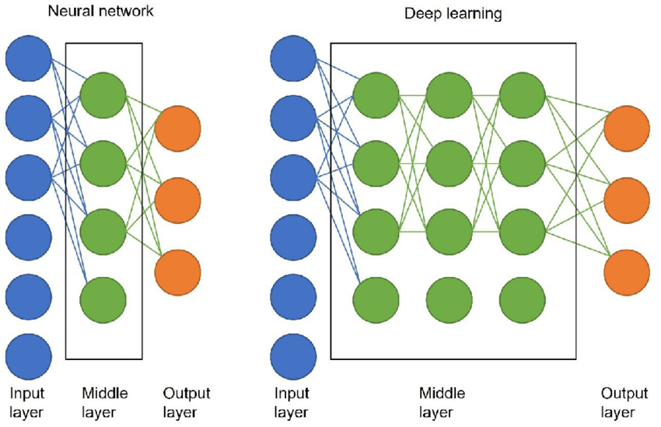
https://www.researchgate.net/publication/355704301_Potential_role_of_artificial_intelligence_in_craniofacial_surgery/figures?lo=1&utm_source=google&utm_medium=organic

